**273/1**

**INTERNAL MOCK EXAMINATIONS 2024.**

**Uganda Lower Secondary Curriculum**

**GEOGRAPHY**

**PAPER 1**

**2024**

**TIME: 2 HOURS 45MINUTES**

**INSTRUCTIONS TO CANDIDATES**

* This paper consists of two sections A and B. It has 5 examination items
* Answer 4 examination items in all
* Section A has two compulsory items
* Section B has two parts I and II. Answer one question from each part
* You may use diagrams where applicable to illustrate your answers
* Any additional item(s) answered will not be scored
* All answers must be written in the answer sheets provided

**SECTION A**

**ITEM 1: MAP SKILLS**

For this item use the east Africa 1:50,000 (UGANDA) map extract LUKAYA series Y732, sheet 79/2, Edition 3.USD and the text below to answer the tasks that follow

1. Musa lives in Sabawali-Ntinzi, an area in the north eastern part of Lukaya, due to its nearness to Kayanja seasonal swamp, him and his family have been experiencing constant flooding, pest and disease infestation and silting. His friend peter who lives in Mutuba II towards the south western part has invited him to shift to his area around Lugasa
2. Help peter illustratethe layout of the area at Mutuba II. The layout should include; major drainage features, relief features, transport routes and vegetation types (07 SCORES)
3. Help Peter to describe to Musa, the nature of the land scape in the area he intends to settle into. (5scores)
4. Advice Peter to inform Musa on which potentials and challenges he is likely to find in his new area. (08scores)

**ITEM 2: PHOTOGRAPHIC SKILLS**

Study the photograph provided below taken from one of the urban centers and the texts below to answer the questions that follow

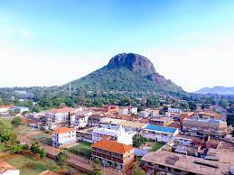

You have assumed the responsibility of a tour guide in Mwea safari tours and travel limited. A group of tourists from Australia are planning to visit that part of the country in the photography. They have booked your company to assist themabout their area of interest shown in the photograph above

1. Draw a landscape sketch of the photograph and on it mark and name
2. Settlements
3. Transport route
4. Relief features
5. Vegetation types (07 SCORES)
6. Describe to the tourists how the feature in the middle background of the photograph was formed (04 SCORES)
7. Explain to the tourists how the people living in that area have benefited from the presence of the feature and the challenges they face as a result of its existence (08 SCORES)
8. You also have a task of explaining to the tourists the area where the photograph was taken from with reasons (01 SCORE)

**SECTION B: ATTEMPT ONE QUESTION FROM EACH PART**

**PART I**

**ITEM 3**

Illegal, unreported and unregulated fishing is a significant concern in east Africa particularly in the western Indian ocean. It poses a threat to the region’s marine ecosystem, food security and economic development. There are also environmental concerns regarding large scale fish farming such as water pollution. Efforts are being made to improve fisheries management to enforce sustainability because the industry remains crucial for food security and livelihood of many communities along the coastlines and in inland water bodies

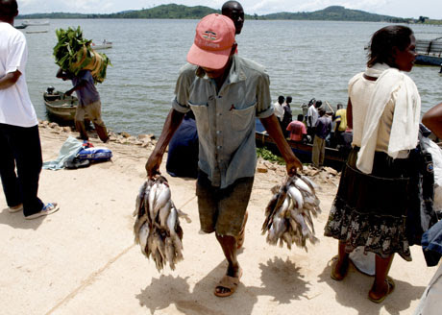

**TASK**

Write an essay of about 250-300 words that will be presented to the ministry of fisheries resources management in the east African parliament highlighting the challenges the fishing industry in east Africa faces and how these can be combated (20 SCORES)

**ITEM 4**

Study the text and figure provided and use them both to answer to answer this item.

Mary and her family have been living in a foreign country for the last forty years. The family plans to return to east Africa and establish their home in any one of the relief regions where they can carry out vegetable farming. However, they have little knowledge about the geography of east Africa.

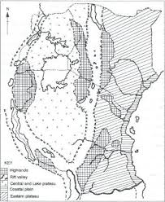

**TASK**

Write an essay of about 250-300 words advising Mary and her family on where they can settle and carry out vegetable farming and the problems, they are likely to face (20 SCORES)

**PART II**

**ITEM 5**

According to the 2018 and the 2024 population survey in Kenya, the population was estimated to be 49,950,000 and growing at a rate of 2.05% per year. At this rate, the country’s population is expected to reach 56,000,000 people by 2024 representing an annual increase of 2,000,000 people per year. Members of the Kenyan community have different views about this rate of population growth. Some see it as a benefit while others as a danger to the country.

The table below shows the population statistics for Kenya between 2018 and 2024

|  |  |
| --- | --- |
| **YEAR** | **POPULATION (MILLIONS)** |
| 2018 | 49,953,304 |
| 2019 | 50,951,450 |
| 2020 | 51,985,780 |
| 2021 | 53,005,615 |
| 2022 | 54,027,487 |
| 2023 | 55,100,586 |
| 2024 | 56,203,030 |

1. Calculate the percentage change of Kenya’s population between 2019 and 2024 (04 SCORES)
2. Draw a suitable graph to represent the information in the table above (07 SCORES)
3. Using the information in the table provided and the text, write an article to be published in the newspaper that will help the Kenyans deal with the concerns of the members in the community (09 SCORES)

**ITEM 6**

You and your classmates have taken a trip to a meteorological station and you have been presented with the climate data collected from a town in a certain part of Africa. You are required to study the data and provide possible responses for the tasks below

|  |  |  |  |  |  |  |  |  |  |  |  |  |
| --- | --- | --- | --- | --- | --- | --- | --- | --- | --- | --- | --- | --- |
| MONTH | J | F | M | A | M | J | J | A | S | O | N | D |
| TEMPERATURE (0C) | 12 | 13 | 14 | 16 | 19 | 22 | 25 | 26 | 24 | 21 | 17 | 13 |
| RAINFALL  (mm) | 110 | 90 | 90 | 60 | 35 | 15 | 3 | 10 | 30 | 80 | 115 | 135 |

1. Use the knowledge you acquired as a student of geography to illustrate the above data in the best statistical way possible (08 SCORES)
2. Describe the features of the climate experienced in the station above (04 SCORES)
3. Advise the people living in that area on the economic activities they can engage in and the problems they are likely to encounter (O6 SCORES)
4. In which hemisphere do you think this data was acquired? (02 SCORES)